Submitted By
Student Name | Deepak Mangla
Roll No | 24/SCA/BCA(Al&ML)/015
Program | BCA(AI&ML)
Subject | OS
Semester | 4
Section/Group | C
Department | School of Computer Applications
Session / Batch | 2024-27
Submitted To
Faculty Name | Dr. Sakshi Gupta
Manav Rachna International Institute of Research and Studies

School of Computer Applications

- Basics of UNIX commands and Implementation of Shell Programming
INPUT:
#!/bin/bash

echo "Current Date:"
date

echo "Present Working Directory:"
pwd

echo "List of files:"
ls

echo "Enter your name:"
read name

echo "Hello $name"

echo "Creating file"
touch file1.txt

echo "Writing into file"
echo "Sample text" > file1.txt

echo "Displaying content"
cat file1.txt

OUTPUT:
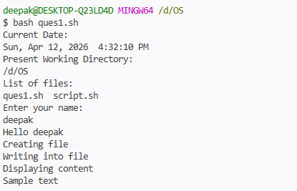

3. Write a C/C++ program for process creation and termination.
INPUT:
#include <stdio.h>
#include <unistd.h>
#include <sys/types.h>
int main() {
pid_t pid;
pid = fork();
if (pid < 0) {
printf("Process creation failed\n"); }
else if (pid == 0) {
printf("Child Process Running\n");
printf("Child PID: %d\n", getpid()); }
else {
printf("Parent Process Running\n");
printf("Parent PID: %d\n", getpid());
printf("Child PID: %d\n", pid); }
printf("Process Terminated\n");
return 0; }
OUTPUT:
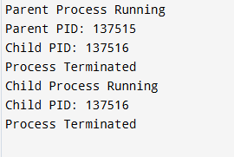
4. Write a C/C++ program for thread creation and termination
INPUT:
#include <stdio.h>
#include <pthread.h>
void* myThread(void* arg) {
printf("Thread is running\n");
pthread_exit(NULL);
}
int main() {
pthread_t t1;
pthread_create(&t1, NULL, myThread, NULL);
pthread_join(t1, NULL);
printf("Thread finished execution\n");
return 0;
}

OUTPUT:
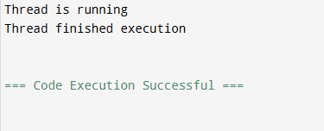

6. Write a C/C++ program to simulate the following non preemptive CPU scheduling algorithms to find average turnaround time and average waiting time. (Provide userinputs) a) FCFS b) SJF c) SRTF d) Priority Based
INPUT:
#include <stdio.h>
int main() {
int n;
printf("Enter number of processes: ");
scanf("%d", &n);

int at[n], bt[n], ct[n], tat[n], wt[n], pr[n

for (int i = 0; i < n; i++) {
printf("\nProcess %d:\n", i + 1);
printf("Arrival Time: ");
scanf("%d", &at[i]);
printf("Burst Time: ");
scanf("%d", &bt[i]);
printf("Priority: ");
scanf("%d", &pr[i]);
}
// -------- FCFS --------
int time = 0;
float avg_tat = 0, avg_wt = 0;

for (int i = 0; i < n; i++) {
if (time < at[i])
time = at[i];

ct[i] = time + bt[i];
time = ct[i];

tat[i] = ct[i] - at[i];
wt[i] = tat[i] - bt[i];

avg_tat += tat[i];
avg_wt += wt[i];
}

printf("\nFCFS Avg TAT = %.2f", avg_tat / n);
printf("\nFCFS Avg WT = %.2f", avg_wt / n);

// -------- SJF (Sort by Burst Time) --------
for (int i = 0; i < n - 1; i++) {
for (int j = i + 1; j < n; j++) {
if (bt[i] > bt[j]) {
int temp;
temp = bt[i]; bt[i] = bt[j]; bt[j] = temp;
temp = at[i]; at[i] = at[j]; at[j] = temp;
}
}
}

time = 0;
avg_tat = avg_wt = 0;

for (int i = 0; i < n; i++) {
ct[i] = time + bt[i];
time = ct[i];

tat[i] = ct[i];
wt[i] = tat[i] - bt[i];

avg_tat += tat[i];
avg_wt += wt[i];
}

printf("\n\nSJF Avg TAT = %.2f", avg_tat / n);
printf("\nSJF Avg WT = %.2f", avg_wt / n);

// -------- Priority (Sort by Priority) --------
for (int i = 0; i < n - 1; i++) {
for (int j = i + 1; j < n; j++) {
if (pr[i] > pr[j]) {
int temp;
temp = pr[i]; pr[i] = pr[j]; pr[j] = temp;
temp = bt[i]; bt[i] = bt[j]; bt[j] = temp;
}
}
}

time = 0;
avg_tat = avg_wt = 0;

for (int i = 0; i < n; i++) {
ct[i] = time + bt[i];
time = ct[i];

tat[i] = ct[i];
wt[i] = tat[i] - bt[i];

avg_tat += tat[i];
avg_wt += wt[i];
}

printf("\n\nPriority Avg TAT = %.2f", avg_tat / n);
printf("\nPriority Avg WT = %.2f", avg_wt / n);

return 0;
}

OUTPUT:
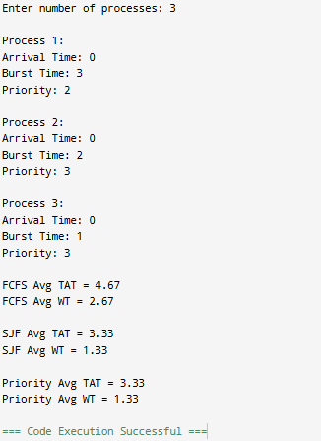
8. Write a C/C++ program to simulate the following preemptive CPU scheduling algorithms to find average turnaround time and average waiting time. (Take User input) Time Quantum = 2 a) Round Robin b) LJF c) LRTF
INPUT:
#include <stdio.h>
int main() {
int n;
printf("Enter number of processes: ");
scanf("%d", &n);
int at[n], bt[n], rt[n], ct[n], tat[n], wt[n];
for (int i = 0; i < n; i++) {
printf("\nProcess %d:\n", i + 1);
printf("Arrival Time: ");
scanf("%d", &at[i]);
printf("Burst Time: ");
scanf("%d", &bt[i]);
rt[i] = bt[i]; // for preemptive
}
// -------- Round Robin --------
int tq = 2, time = 0, done;
float avg_tat = 0, avg_wt = 0;

do {
done = 1;
for (int i = 0; i < n; i++) {
if (rt[i] > 0) {
done = 0;
if (rt[i] > tq) {
time += tq;
rt[i] -= tq;
} else {
time += rt[i];
ct[i] = time;
rt[i] = 0;
}
}
}
} while (!done);
for (int i = 0; i < n; i++) {
tat[i] = ct[i];
wt[i] = tat[i] - bt[i];
avg_tat += tat[i];
avg_wt += wt[i];
}
printf("\nRound Robin Avg TAT = %.2f", avg_tat / n);
printf("\nRound Robin Avg WT = %.2f\n", avg_wt / n);

// Reset remaining time
for (int i = 0; i < n; i++)
rt[i] = bt[i];

// -------- LJF (Longest Job First) --------
for (int i = 0; i < n - 1; i++) {
for (int j = i + 1; j < n; j++) {
if (bt[i] < bt[j]) {
int temp;
temp = bt[i]; bt[i] = bt[j]; bt[j] = temp;
}
}
}

time = 0;
avg_tat = avg_wt = 0;

for (int i = 0; i < n; i++) {
ct[i] = time + bt[i];
time = ct[i];

tat[i] = ct[i];
wt[i] = tat[i] - bt[i];

avg_tat += tat[i];
avg_wt += wt[i];
}

printf("\nLJF Avg TAT = %.2f", avg_tat / n);
printf("\nLJF Avg WT = %.2f\n", avg_wt / n);

// -------- LRTF (Longest Remaining Time First) --------
int complete = 0;
time = 0;
avg_tat = avg_wt = 0;

while (complete != n) {
int idx = -1, max_rt = -1;

for (int i = 0; i < n; i++) {
if (rt[i] > max_rt && rt[i] > 0) {
max_rt = rt[i];
idx = i;
}
}

if (idx != -1) {
rt[idx]--;
time++;

if (rt[idx] == 0) {
complete++;
ct[idx] = time;
}
}
}

for (int i = 0; i < n; i++) {
tat[i] = ct[i];
wt[i] = tat[i] - bt[i];

avg_tat += tat[i];
avg_wt += wt[i];
}

printf("\nLRTF Avg TAT = %.2f", avg_tat / n);
printf("\nLRTF Avg WT = %.2f\n", avg_wt / n);

return 0;
}
OUTPUT:
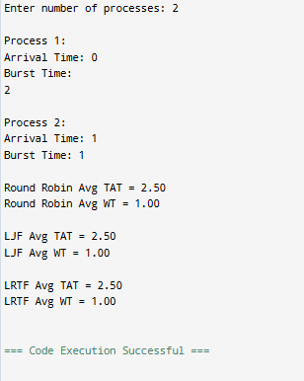

9. Implementation of CPU Scheduling: (i) Highest Response Ratio Next (HRRN) and (ii) Multilevel Queue
INPUT:
#include <stdio.h>

int main() {
int n;
printf("Enter number of processes: ");
scanf("%d", &n);

int at[n], bt[n], ct[n], tat[n], wt[n], done[n];
float rr[n];

for (int i = 0; i < n; i++) {
printf("\nProcess %d:\n", i + 1);
printf("Arrival Time: ");
scanf("%d", &at[i]);
printf("Burst Time: ");
scanf("%d", &bt[i]);
done[i] = 0;
}

int time = 0, completed = 0;
float avg_tat = 0, avg_wt = 0;

while (completed < n) {
int idx = -1;
float max_rr = -1;

for (int i = 0; i < n; i++) {
if (at[i] <= time && done[i] == 0) {
wt[i] = time - at[i];
rr[i] = (float)(wt[i] + bt[i]) / bt[i];

if (rr[i] > max_rr) {
max_rr = rr[i];
idx = i;
}
}
}

if (idx != -1) {
time += bt[idx];
ct[idx] = time;

tat[idx] = ct[idx] - at[idx];
wt[idx] = tat[idx] - bt[idx];

avg_tat += tat[idx];
avg_wt += wt[idx];

done[idx] = 1;
completed++;
} else {
time++;
}
}

printf("\nHRRN Avg TAT = %.2f", avg_tat / n);
printf("\nHRRN Avg WT = %.2f\n", avg_wt / n);

return 0;
}
OUTPUT:
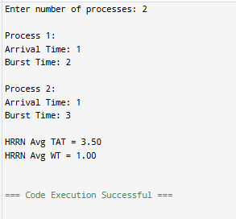

13. Producer-Consumer Problem using Semaphores and Reader Writer Problem
INPUT:
#include <stdio.h>
#include <pthread.h>
#include <semaphore.h>

int readcount = 0;
sem_t mutex, wrt;

void *reader(void *arg) {
sem_wait(&mutex);
readcount++;

if (readcount == 1)
sem_wait(&wrt);

sem_post(&mutex);

printf("Reader is reading\n");

sem_wait(&mutex);
readcount--;

if (readcount == 0)
sem_post(&wrt);

sem_post(&mutex);
}

void *writer(void *arg) {
sem_wait(&wrt);

printf("Writer is writing\n");

sem_post(&wrt);
}

int main() {
pthread_t r1, r2, w1;

sem_init(&mutex, 0, 1);
sem_init(&wrt, 0, 1);

pthread_create(&r1, NULL, reader, NULL);
pthread_create(&r2, NULL, reader, NULL);
pthread_create(&w1, NULL, writer, NULL);

pthread_join(r1, NULL);
pthread_join(r2, NULL);
pthread_join(w1, NULL);

return 0;
}

OUTPUT:
